**Payroll System**

**POSEgg003**

HUEVO – FEBRUARY 2017

|  |  |  |
| --- | --- | --- |
| **SCRUM TEAM** | **SPRINT NAME AND DURATION** | **CHANGES** |
| Huevo | POSEgg003  4/Feb/17  to  18/Feb/17 | * **Employee Information Page** |

**POSEgg003**

This story includes the creation of Employee Information page. The Employee Information Page can view the basic information of the employees. The team are creating employee information page were you users can access add, view and edit to information of employees. The user must go to login page to validate the username and password to provide security of the user.

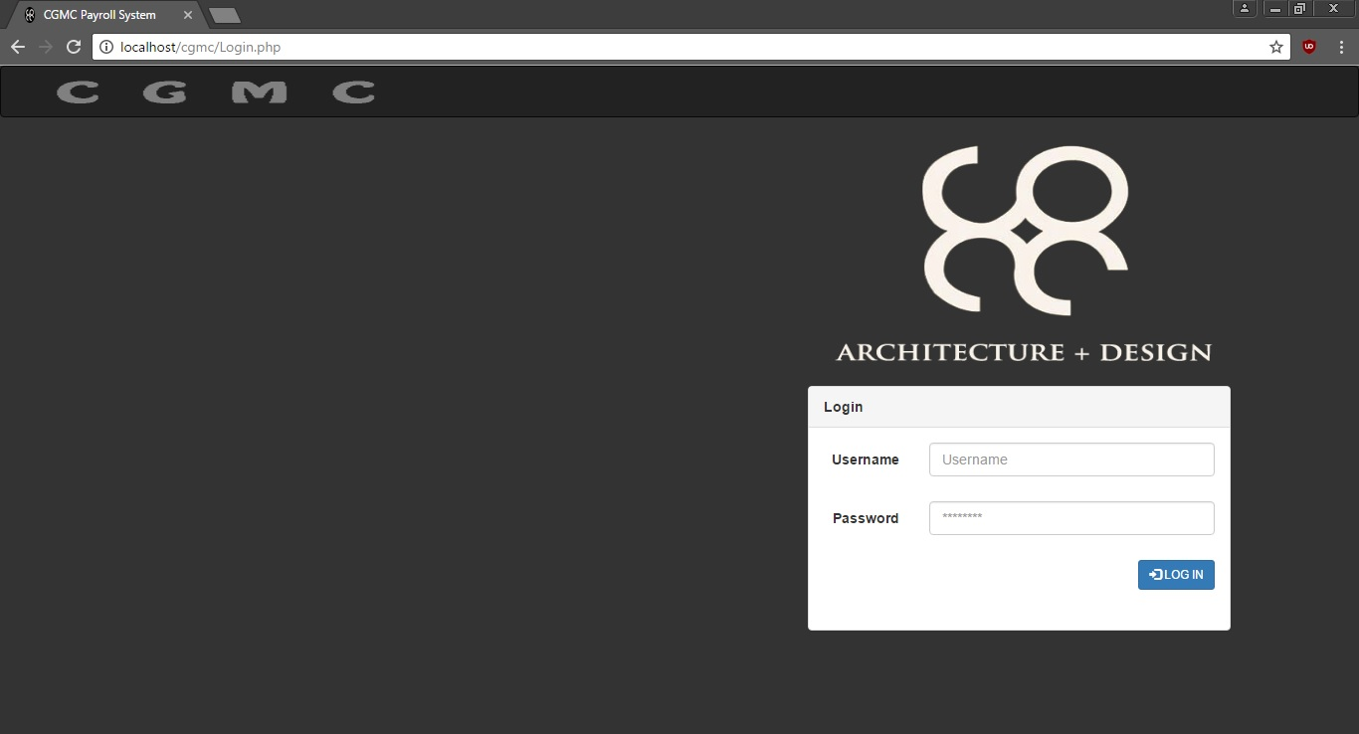

1. Adding Login Page Procedures

Step1: Click Start Button

Step2: Open Xampp and Start MySql , Apache

Step3: Open any available browser

Step4: Browse “localhost/cgmc”

Step5:Click “loginpage.php”

1. Process of Authentication Procedures

Step1: Insert Valid Credentials (Username, Password) then click the login button

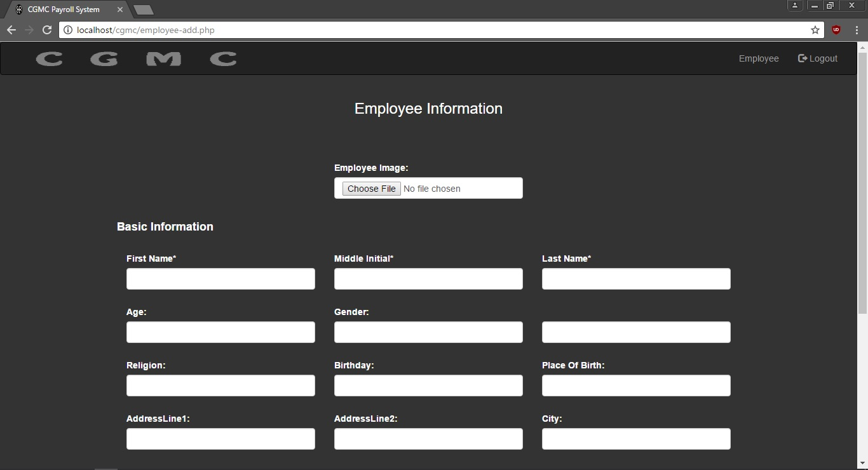

1. For Adding Employee, the admin is the only user to access in this page that can input the basic information about new employee to have a new record. Procedures are:

Step1: Click the add employee button

Step2: Upon clicking, Admin will able to input data. Some of this information is required such as First Name, Middle Initial, Last Name, Gender, Birthday, Address and Contact Number and the rest are not required.

Step3: After filling information, click the button Save Employee to save to database.

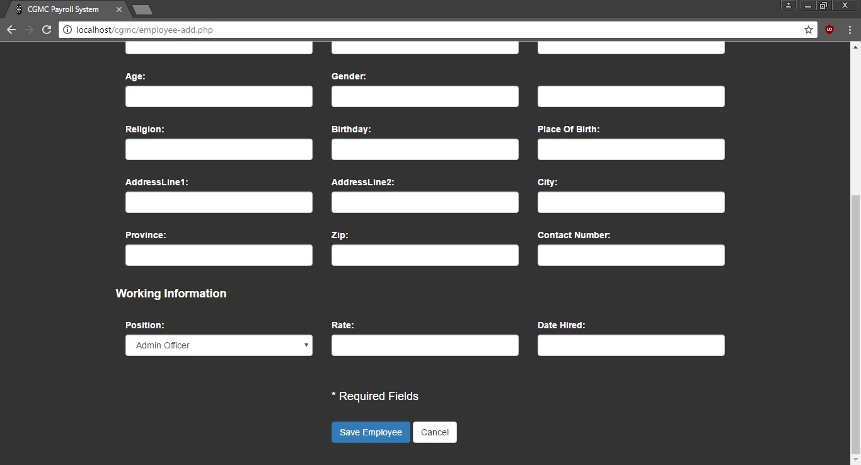

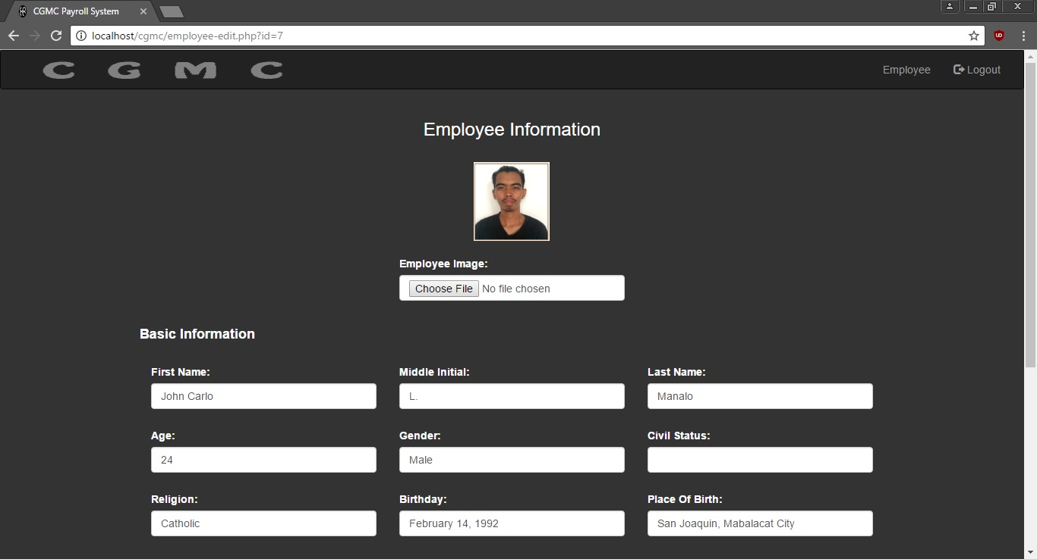

1. Process to Edit Employee Information, the admin is the only user to access in this page that can edit the basic information of employees. Procedures are:

Step1: Click View Information

Step2: Upon clicking, Admin will able to input or edit information. Some of this information is required such as First Name, Middle Initial, Last Name, Gender, Birthday, Address and Contact Number and the rest are not required.

Step3: After editing information, click the button Save Employee to save to database.

1. Process to Logout. The user must Click the Button Logout to go to Login page.